**MCSE – Level 1 Lab 1**

**Objective:**

This lab will highlight some of the similarities and differences between the 3 most popular Windows client operating systems in use today. You will compare and contrast the user interface on Windows 7, Windows 8, and Windows 10.

**Procedure**

Throughout the lab, you will have to capture certain screens and paste them into a Word document. You will then submit the Word document to the instructor for marking.

___ Create a Word document. Save it as ***lastname*_Lab1** where “lastname”

is your last name. For instance, Clairmont_Lab1.

___ Under each screen capture, type the number of the capture followed by your last name. For example, screen capture 1 would have **#1 Clairmont** under it. Screen capture 2 would have **#2 Clairmont** under it.

___ Start Ottawa, Hamilton, and Saskatoon in VMWare. Ottawa is a Windows 7 machine, Hamilton is a Windows 8 machine and Saskatoon is a Windows 10 machine.

**Ottawa (Windows 7)**

___ Log into Ottawa as the Administrator. (To log in with VMWare, press **CTRL+ALT+insert** instead of CTRL+ALT+Del). The password is **P@ssw0rd** where “0” is a zero.

Let’s open a DOS window and check the IP address of Ottawa.

___ Click on the **Start** button and type **cmd** here.

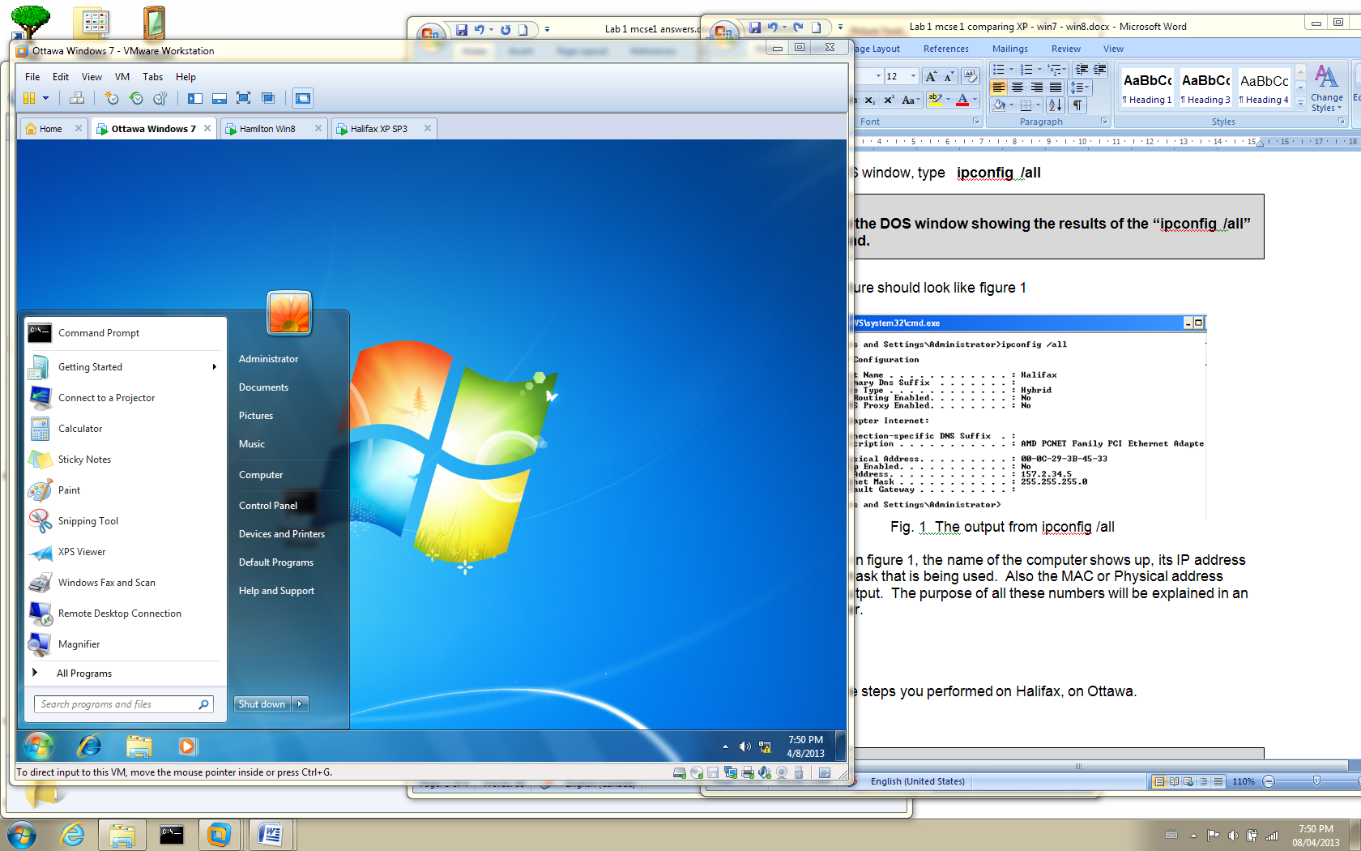

Fig. 1 Type **cmd** in the box shown above

Let’s change the color on the DOS window so it is more readable.

___ Right-click on the little black box in the upper left corner on the blue bar at the top of the window. Select **Properties** and then click on the **Colors** tab.

___ Make the Screen Background white and the Screen Text black.

___ Click on **OK**. On the **Apply Properties** window, click on “**Save properties for future Windows with same title**” and click on **OK**.

___ In the DOS window, type **ipconfig /all**

**1. Capture the DOS window showing the results of the “ipconfig /all” command on Ottawa. Make sure the text is black and the background is white. Make sure the name “Ottawa” shows up in the capture.**

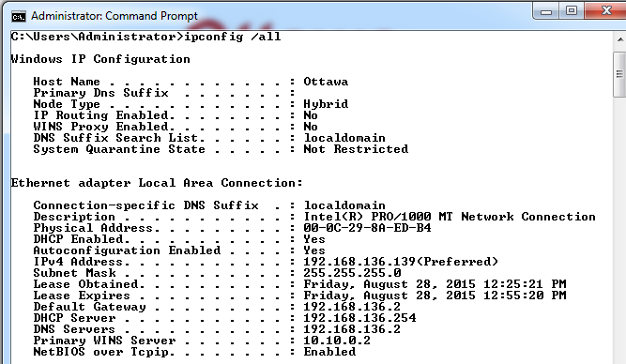

Fig. 2 The results of typing **ipconfig /all** on Ottawa

You can see in figure 2, the name of the computer shows up, its IP address and the subnet mask that is being used. Also the MAC or Physical address appears in the output. The purpose of all these numbers will be explained in an upcoming lecture.

**Hamilton: (Windows 8)**

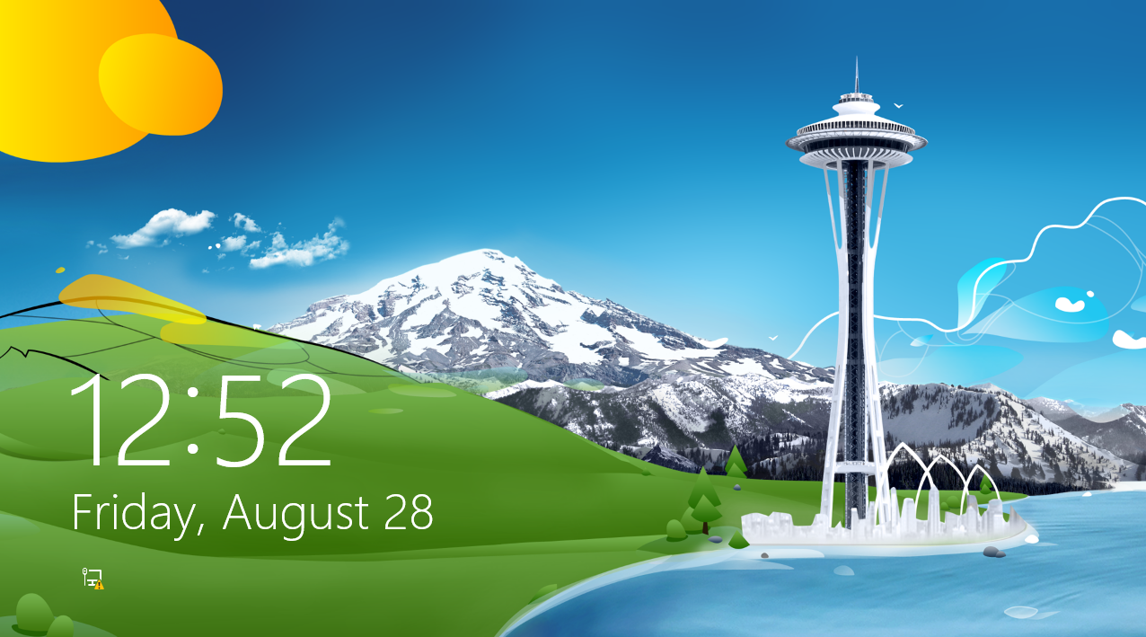

The welcome screen for

Windows 8 is shown in figure 3.

___ Log in with CTRL + ALT + Insert. The welcome screen disappears and the login window appears.

___ Log in as the Administrator. Login with the password; **P@ssw0rd**.

Fig. 3 Windows 8 welcome screen

The start screen is shown in figure 4. The reason all those tiles appear is

because Windows 8 is designed as a touch screen interface. This is similar to

what you find on smart phones and tablets.

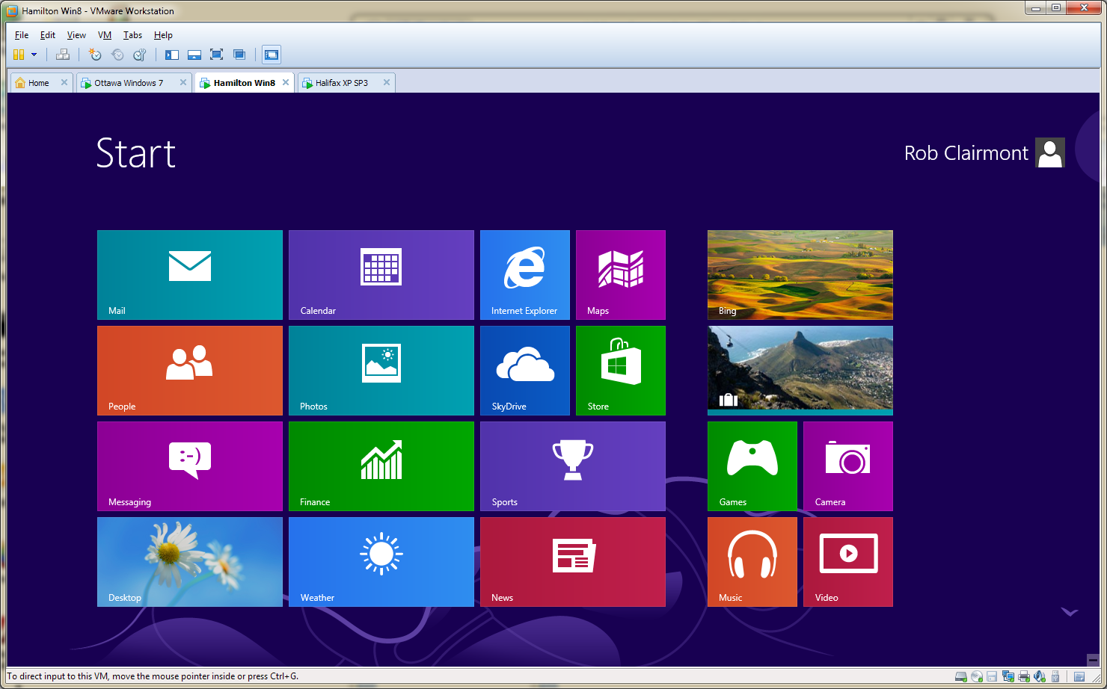

Fig. 4 The **Start window** for windows 8

So how do we get to the DOS window from here? You can just type the

commands you want to run while in the Start screen.

___ Click on the dark blue background and then type **cmd**.

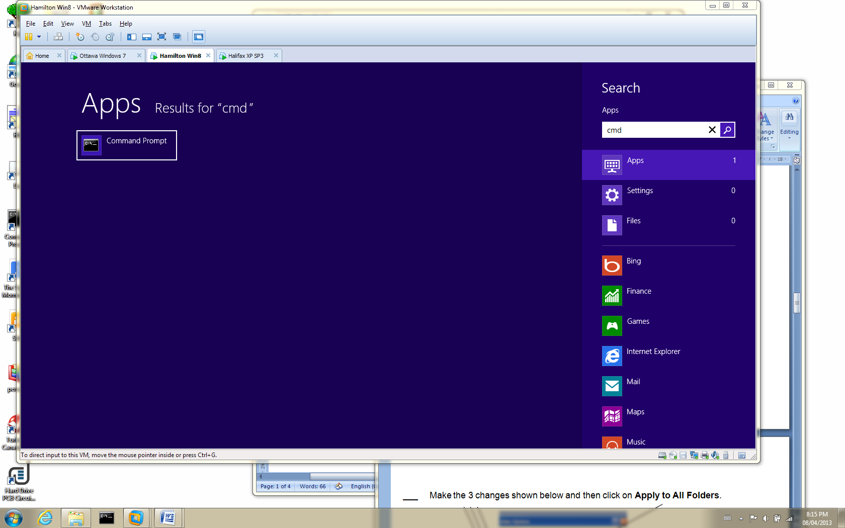

Fig. 5 The command prompt option

___ Click on the Command prompt box. (Command prompt is another name for DOS window).

___ Configure the DOS window so it has black letters on a white background.

___ Type **ipconfig /all**.

**2. Capture the DOS window showing the results of the “ipconfig /all” command on Hamilton. Make sure the text is black and the background is white. Make sure the name “Hamilton” shows up in the capture.**

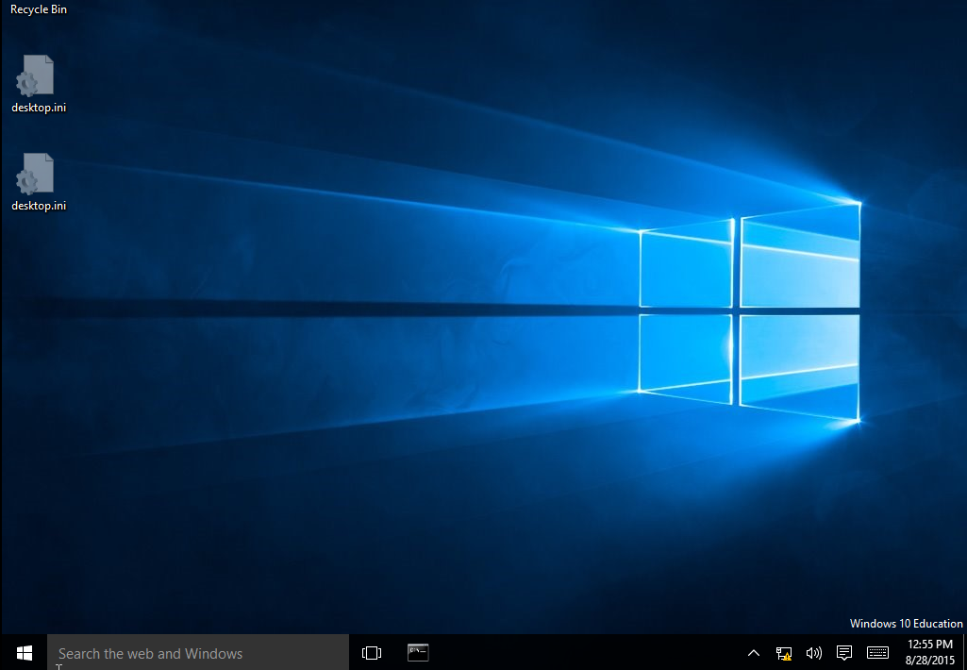**Saskatoon: (Windows 10)**

___ Log in with CTRL + ALT + Insert. The welcome screen disappears and the login window appears.

___ Log in as the Administrator. Login with the password; **P@ssw0rd**. Figure 6 appears.

***Start Button***

Fig. 6 The initial screen that appears after logging into Widows 10

So how do we get to the DOS window from here?

___ Click on the Start button (Window icon) in the lower left corner of the screen in figure 6.

You can see a command prompt tile on the start screen. Normally, this is not

present. The instructor has pinned the command prompt to the start screen for

your convenience. Let’s find out how you would find the command prompt if it

was not pinned to the start screen.

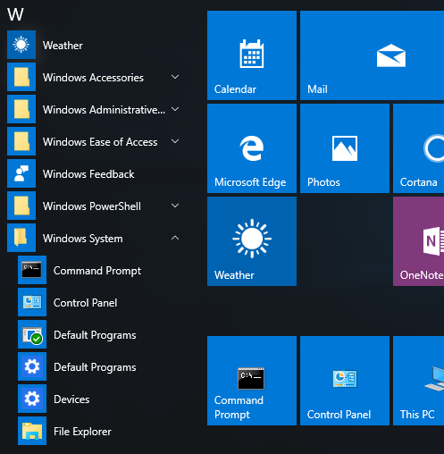___ Click on **All Apps** from the list that shows up just above the start button.

___ Click on **Windows System** and the **Command Prompt** icon should be visible.

___ Click on the Command prompt icon.

___ Configure the DOS window so it has black letters on a white background.

___ Type **ipconfig /all**.

Fig. 7 Finding the command prompt

**3. Capture the DOS window showing the results of the “ipconfig /all” command on Saskatoon. Make sure the text is black and the background is white. Make sure the name “Saskatoon” shows up in the capture.**

**User Profiles**

Let’s take a look at the difference between the 3 operating systems in regards to

the user profiles found on the hard drives.

As mentioned in the lecture, each user has a profile which consists of a number of folders and files that contain the information regarding user’s environment. The way you set up your desktop with your favorite wallpaper and icons is preserved in your profile. The changes you make, such as adding new icons to the desktop, are saved in the profile. That way, when you log in the next time the changes are still there.

**Ottawa: (Windows 7)**

Let’s check out the profile in Window 7.

___ To open the Windows Explorer, click on the folder in the task bar.

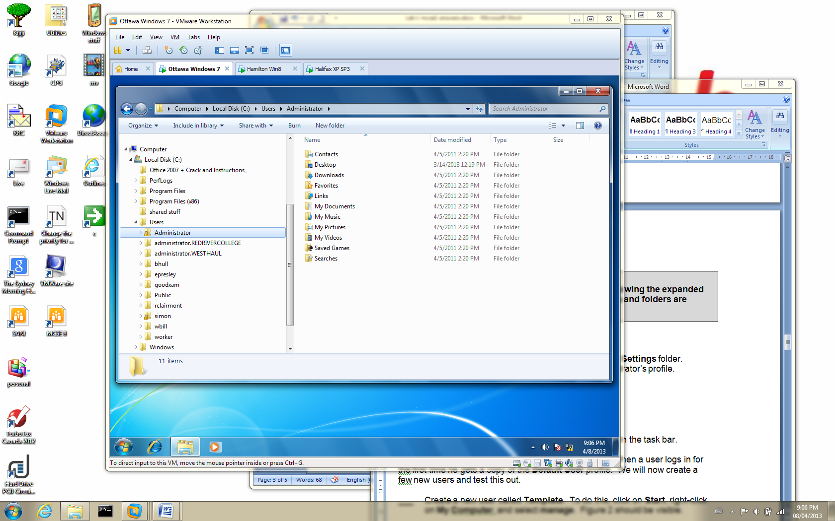

Fig. 8 The Windows Explorer in Windows 7

___ Click on the Administrator’s folder in the **Users** folder. Notice there are no files in the right-hand pane.

We have to configure the Explorer to display the files. We need to select **Tools**

from the Explorer main menu. The problem is, the **Tools** option does not show

up.

___ Press the **Alt** key and the **Tools** option appears. Select **Folder Options** and then click on the **View** tab.

___ Make the 4 selections shown in figure 9. Click on **Apply to Folders** and then click on **OK**.

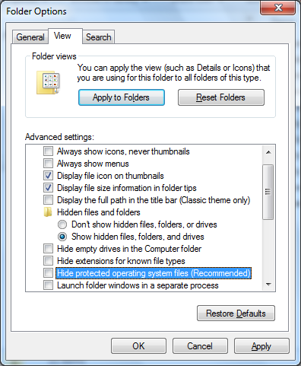

***Make these 4 selections.***

Fig. 9 Make the 4 selections shown above

Take note of two things:

1. Windows 7 keeps the user profiles in the **Users** folder.

2. There is a file called **NTUSER.DAT** in the Administrator’s profile.

**4. Capture the view in the Windows Explorer showing the expanded view of the Administrator’s profile so the files and folders are visible on the right-hand pane.**

**Hamilton (Windows 8)**

___ Press the Windows key. This is the key with the little window on it just to the left of the space bar. This will display the Start window with all the tiles.

___ Click on the **Desktop** tile and then the folder tile on the task bar.

___ Expand the **Users** folder and click on the **Administrator** folder. This is the Administrator’s profile.

Just as with Windows 7, the files are hidden so we must configure the Explorer so we can see the hidden files.

___ To view the folder options, click on **View** and then **Options**. Select **Change folder and search options**.

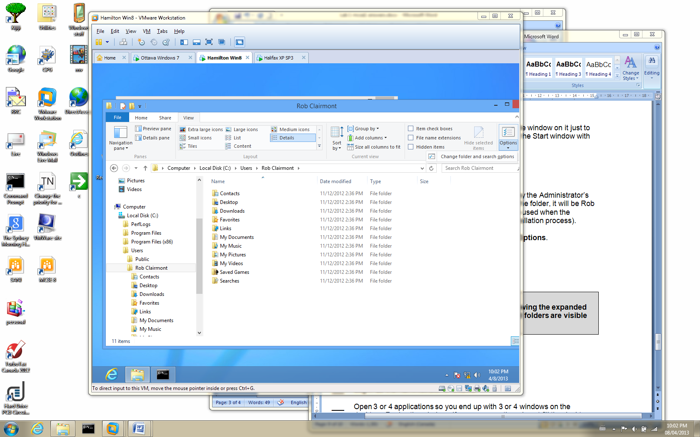

Fig. 10 Accessing the folder options in Windows 8

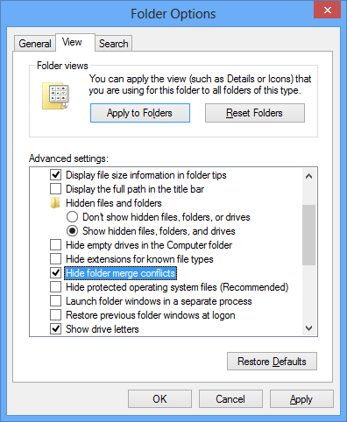

Fig. 11 Change the 4 options shown above

**5. Capture the view in the Windows Explorer showing the expanded view of the Administrator’s profile so the files and folders are visible on the right-hand pane.**

**Saskatoon (Windows 10)**

___ Click on the **Start** button; (see figure 6)

___ Click on the **File Explorer** option from the menu that appears above the **Start** button.

___ Expand the **Users** folder and click on the **Administrator** folder. This is the Administrator’s profile.

Just as with Windows 7 and Windows 8, the files are hidden so we must configure the Explorer so we can see the hidden files.

___ Perform the same steps you did for Windows 8 to make the files visible in the Explorer.

**6. Capture the view in the Windows Explorer showing the expanded view of the Administrator’s profile so the files and folders are visible on the right-hand pane.**

**Aero Features**

**Ottawa: (Windows 7)**

**Areo Shake:**

___ Log in as the Administrator of Ottawa.

___ Open 3 or 4 applications so you end up with 3 or 4 windows on the desktop. Resize the windows if necessary so they do not overlap each other.

___ Hold down the left mouse button while the cursor is hovering over the title bar at the top of one of the windows.

___ Shake the window like a dog trying to tear apart a cat.

The other windows should minimize. Shake the window again and the minimized windows should spring back to their original size.

**Areo Snap:**

___ Drag one of the windows to the top of the desktop. The window should

expand to full size.

___ Drag the window from the top of the desktop and the window should go back to its original size.

**Areo Peek:**

___ Move the cursor to the lower right corner of the desktop. The open windows should turn transparent so you can see the desktop.

**7. Capture the desktop showing the transparent windows.**

___ Shutdown Ottawa.

**Hamilton (Windows 8)**

Shutting down Windows 8 is a little more difficult.

___ Drag the mouse to the lower right corner. The menu shown on the right in figure 12 will appear. This is called the “charms” menu.

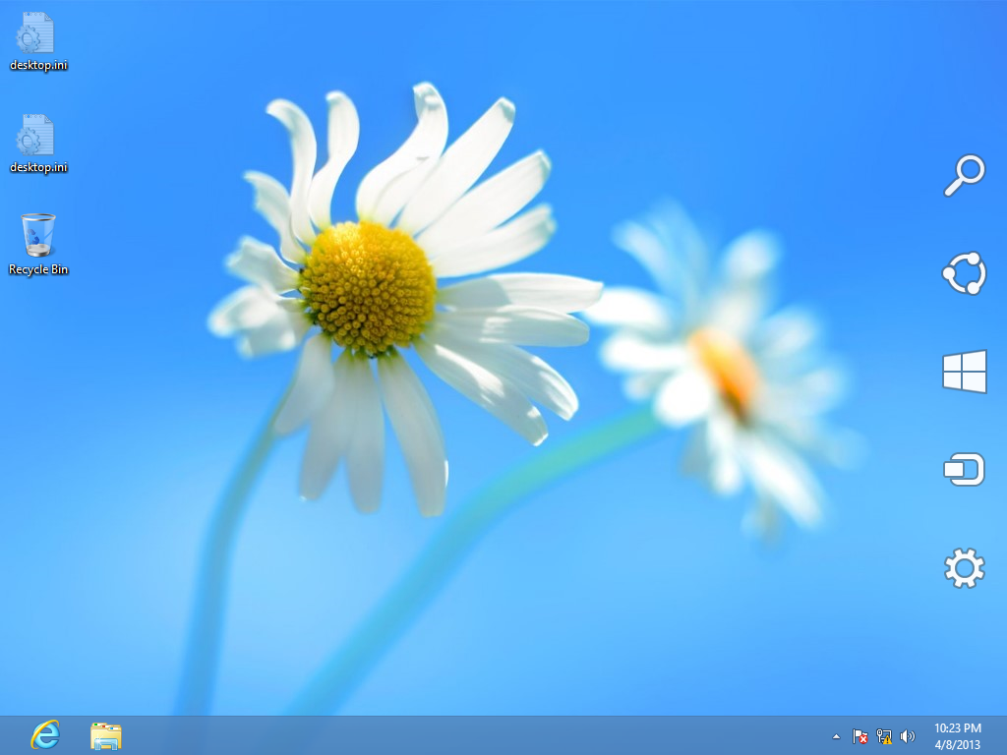

Fig. 12 The “charms” menu.

___ Click on the gear.

**8. Capture the view shown in figure 13.**

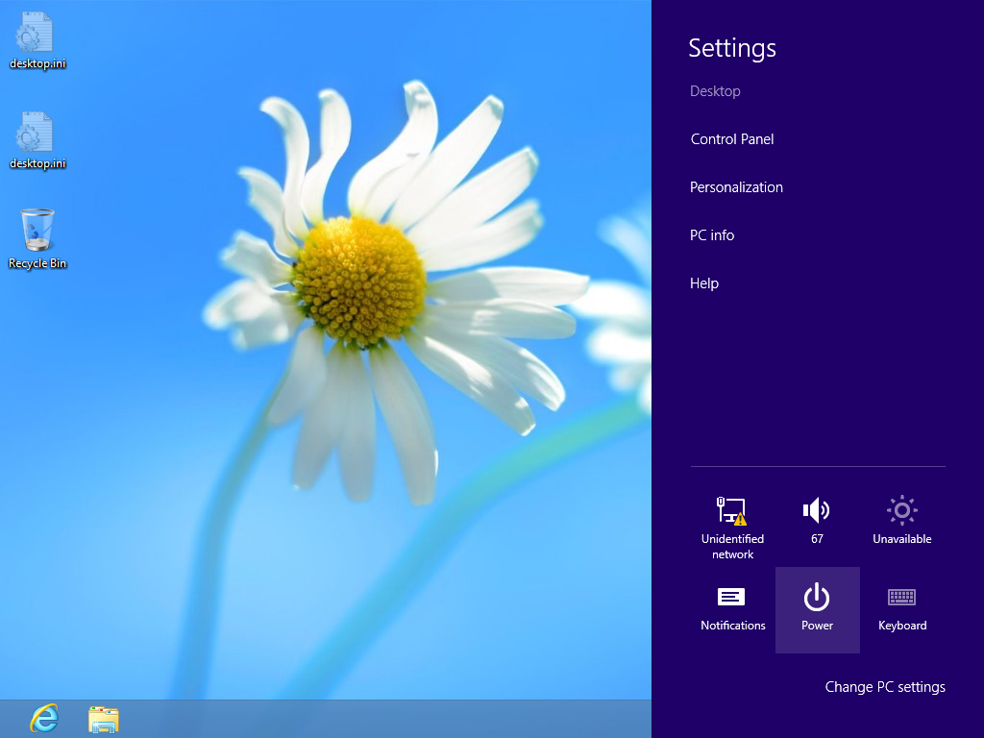

Fig. 13 Click on **Power**

___ Click on **Power** in figure 13.

___ Click on **Shutdown**.

**Saskatoon (Windows 10)**

Shutting down Windows 10 is similar to Windows 7.

___ Click on the **Start** button and select **Power** and then **Shutdown**

That’s enough for the 1st lab. Give a copy of your answer file to the instructor.



Yahoo !!

Done !!!